**AWS ADVANCE -LU PROJECT 7:**

**Project Name: Project-DevOps-Jenkins-Installation and Configuration on Linux**

https://pkg.jenkins.io/redhat-stable/

Install java

sudo wget -O /etc/yum.repos.d/jenkins.repo <https://pkg.jenkins.io/redhat-stable/jenkins.repo>

sudo rpm --import <https://pkg.jenkins.io/redhat-stable/jenkins.io.key>

Screenshot for importing rpm:

yum install Jenkins

extract the password from the location

Screenshot for extracting the password

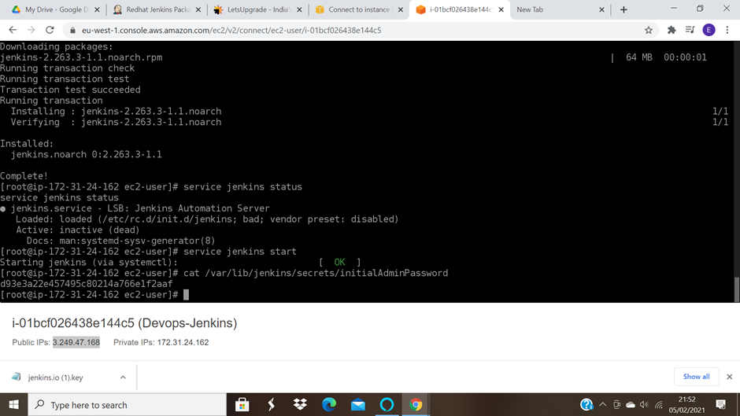

skip installing plugins

Start using jenkins

Change the admin password

Create a new job

Build step: execte shell

echo "hello"

Screenshot for the executed shell:

build the job

Screenshot for the successful build:

